eShel Processing Guide

* In the eShel-red-pc, go to the Total Commander program.
* Copy the relevant files from the Z drive to c:/users/mizpe/documents/audela/images
* If for some reason the computer connection to drive Z is marked with a red X - you have to reconnect. Choose the drive and when prompted enter user: mizpe and password : ne'Gev.
* When the file copying is done, open the Audela program, press Session, and in the main directory input, change the date to the relevant date. Press Apply and then Ok.
* **Press Setup and Save setup.**
* **Verify then the Auto processing option is unchecked!**

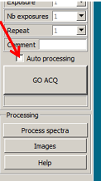

* Press Process spectra.
* When having observed a specific star twice or more at the same night, we want to combine the files into one.
* To do this, after pressing Process spectra, move to the raw images tab, press refresh , mark the specific star and press unmake serie (on each of the star's files). The file will then be moved to the lower screen.
* Copy (ctrl+c) the SeriesId of the star's first file.
* Press Make series. A window is opened and there, in the first row, paste the series id (ctrl+v). In the drop-down list on the right, change from BIAS to Object. Press Ok. (do this for every file you want to merge).

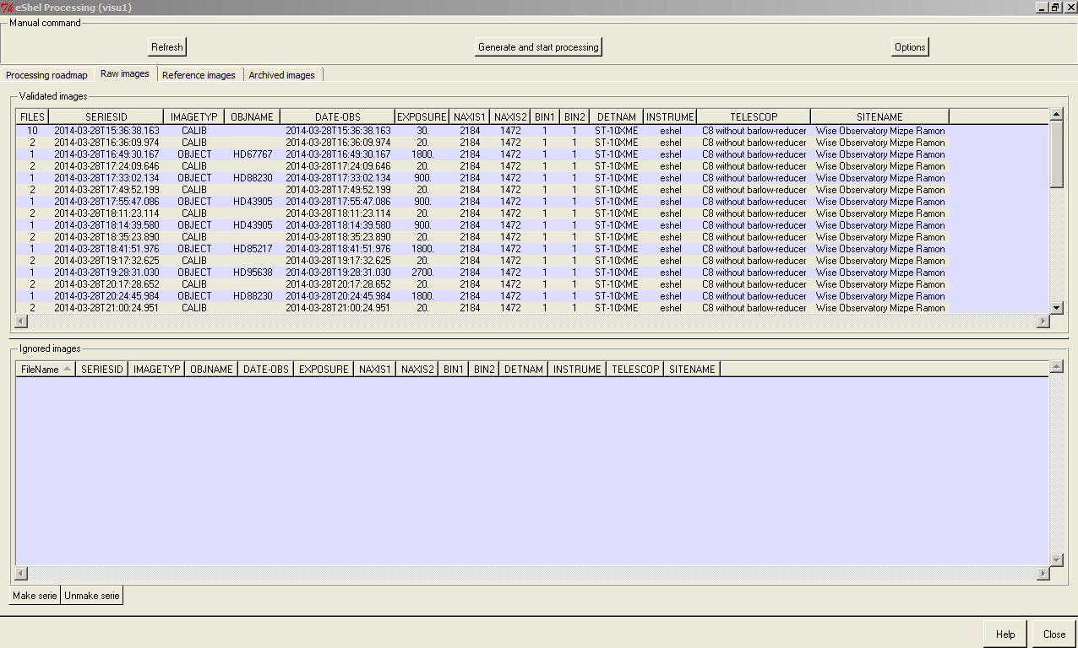

* Go back to Processing roadmap and press refresh. Make sure everything was loaded and merged (when necessary).

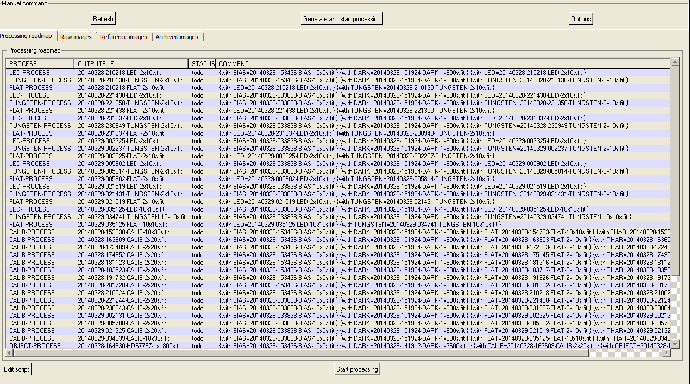

* Press Start processing. Go to sleep.
* **If you find that Audela crashed**. Close the program (press OK on the crash message). Run Audela again. Go back to Processing tab and press refresh. You will see the part of the files that were not processed yet. Press Start processing- and hope for the best. If this happens again - repeat these steps.
* After processing – check the calibration quality:
  + Go to the terminal window and scroll up to see the calibration result tables: 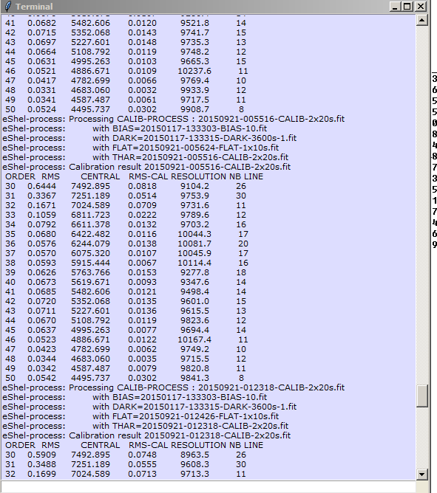
  + Look on the RMS CAL column. You should see values similar to the values presented in the picture. If you see values which are larger (>~0.1) do not continue with the processing and call or SMS Micha (052-8212507).
* When processing is done (on the next day), press the eShel PPA icon on the desktop. In the window that is opened, go to C:\Users\mizpe\Documents\audela\images, mark the relevant folder and press Select Folder.
* When the PPA script is done press the eShel PPB icon on the desktop.