eShel Guiding with Maxim DL

includes also the previous guide:

Binning in the guider camera in the MaximDL program

# Guiding on the pinhole

This is part of the Wise_man pdf file with some updates and extensions. The new changes are marked in red font.

Open a VNC to the pi206 computer.

— In the pi2006 VNC window click twice on the MaximDL icon that is on the desktop. The

MaximDL interface will be opened.

— Click on the “toggle camera control” button, and in the “camera control” window click

on “setup” tab.

— Setup camera 1 on SBIG universal and on ST-i.

— Setup camera 2 on simulator (camera 2 is not going to be used).

— Connect the cameras. Now you have the ST-i as camera 1. Camera 2 is not relevant.

— Check the options of camera1 and make sure they correspond to what is seen here:

Both flips should be unchecked.

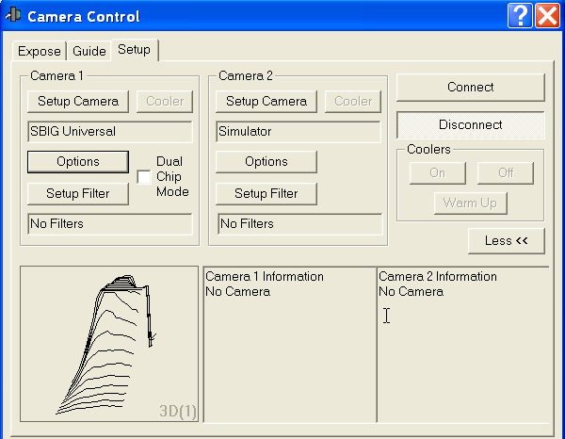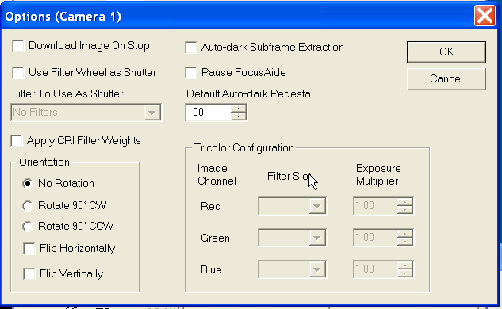

— In the “Guide” tab set the “Aggressiveness” to x=2 y=2. Then press “Settings” and setup

the guide parameters:

XSpeed= −-4.34 YSpeed= 3.12 and angle= 179

These are the current parameters!

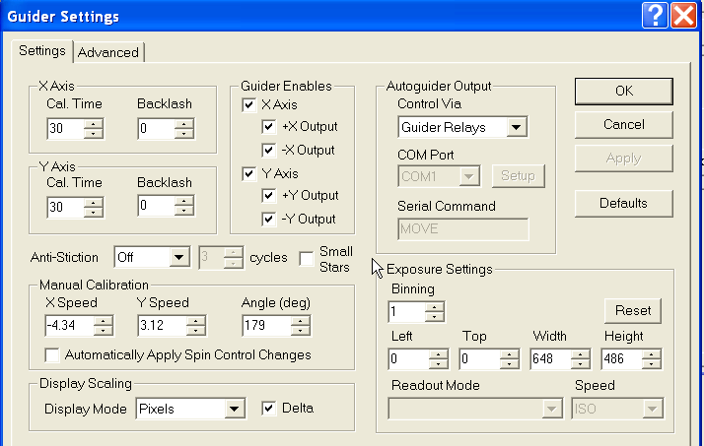

~~The previous params were: XSpeed= −3.21 YSpeed= 2.86 and angle= 0.76~~

(These parameters may change - Check the observers folder in the eShel web-site). Once the parameters are set press “Apply” to save and close the “Settings”.

— Choose the expose tab and make sure “Camera 1” radio button is checked.

— In Exposure Preset Choose eShel cont. Choose Continuous and press Start. Look

on the live video from the ST-i CCD.

— In the control box turn on the Mirror and the ThAr lamp on the calibration unit. You

should see a bright round field appearing in the video and the fiber pinhole as a dark dot.

(If the image is saturated adjust exposure time - 0.01s should work).

— Use Toggle Screen Stretch to adjust the dynamic range of the image so you can see

# Binning in the guider camera in the MaximDL program

1. When observing a faint star ( magnitude 9.2 or more), you may need to enhance the counts received in each pixel for proper guiding (this is relevant when you get too often "star faded" message from the guider). This enhancement is done by "binning" which means that we sum the counts of several neighboring pixels. Binning of 2x2 means that we sum a 2x2 box of pixels. This of course reduces the size of the image by factor of 2 in both x and y axes. This means that the coordinates of the pinhole in the "binned" image will be half their original value.
2. In the MaximDL program, go to the guide tab and press Settings. There, change the Binning option from 1 to 2. Press Ok.

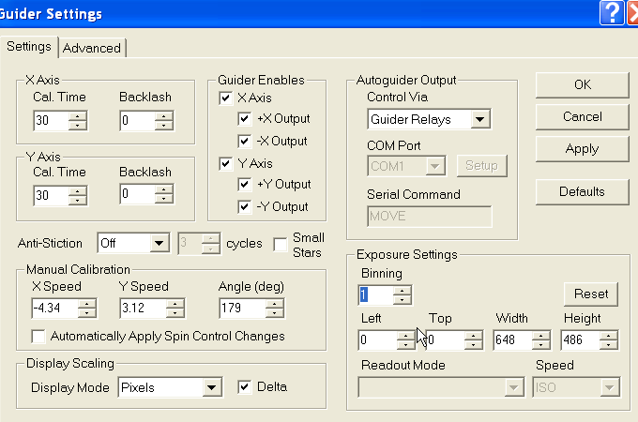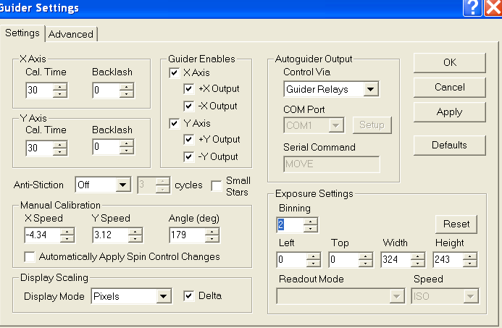

1. Change the pinhole coordinates to half of what they were (for example, if the pinhole coordinates are 404/284, change them to 204/142).
2. When moving to the next star, don't forget to change/check the binning! Press reset and then change the binning.