Using Aladin Finder Charts in Simbad
Many thanks to Avi Burshteyn for contributing to this note.
Use images from Aladin view in SIMBAD data base to remove ambiguity of star identification. This happens if you navigate to a star and get two stars in the field of view of the guider (PI2006 – MaximDL).
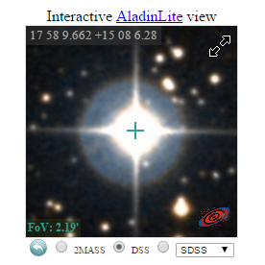Open the SIMBAD catalogue and search for the star using its ID (HD163930 for example).

At the lower left you will get an Aladin View image of the neighborhood of the star. Click on the image and use the mouse scroll wheel to zoom to a FOV of about 2 arc minutes. (the FoV=field of view – is indicated in the lower right corner of the image). This is the approximate size of the FOV in the guider image.

You can verify the identification by taking a long exposure and see where the fainter stars are.

